Solid Waste Infrastructure for Recycling (SWIFR) Grant Program
The Solid Waste Infrastructure for Recycling grant program is a new grant program authorized by the Save Our Seas 2.0 Act and funded through the Infrastructure Investment and Jobs Act.
The Infrastructure Investment and Jobs Act, also referred to as the Bipartisan Infrastructure Law, provides $275 million for solid waste infrastructure for recycling grants.
- Allocated as $55 million per year from FY 22 to 26 to remain available until expended.
- Additional $2.5 million provided to EPA in FY 22 funding to implement the program.

Solid Waste Infrastructure for Recycling Grants:
- For states, territories, and the District of Columbia to improve solid waste management planning, data collection, and program implementation.
Goal of Grants:
- Implement a strategy to improve post-consumer materials management and infrastructure
- Support improvements to local post-consumer materials management and recycling programs; and
- Assist local waste management authorities in making improvements to local waste management systems
- Only for Territories : Equipment and Construction
Eligible Applicants:
- U.S. States (Only one applicant per State)
- Political subdivision of states
- U.S. Territories (Puerto Rico, Virgin Islands, Guam, American Samoa, and the Commonwealth of Northern Mariana Islands
Deadlines:
- Submit Notices of Intent to participate by December 15, 2022 to SWIFR@epa.gov
- Submit grant submittal by April 30, 2023.
- TIMELINES
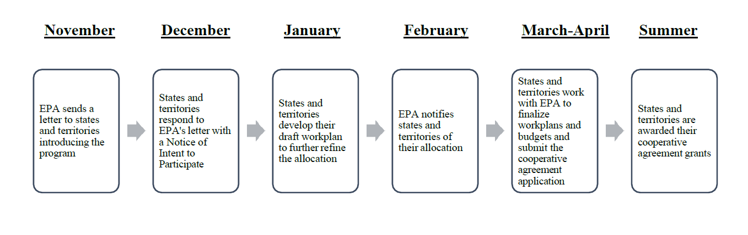

EPA Webinars:
- Grants for States and Territories
  - Overview of program, review notice of intent to participate, and answer questions (same presentations)
    - December 1, 2022 @ 6:00pm – 7:00pm (EST)
  - Review program guidance and work plans, and answer questions (same presentations)
    - December 19, 2022 @ 2:00pm – 3:30pm (EST)
    - January 3, 2023 @ 6:00pm – 7:00pm (EST)
- Grants for Political Subdivisions
  - Overview of program, review notice of intent to participate, and answer questions (same presentations)
    - December 5, 2022 @ 2:00pm – 3:30pm (EST)
    - December 7, 2022 @ 6:00pm – 7:00pm (EST)
  - Review procurement, subawards, and answer questions (same presentations)
    - December 13 2022, @ 2:00pm – 3:30pm (EST)
    - December 19 2022, @ 6:00pm – 7:00pm (EST)

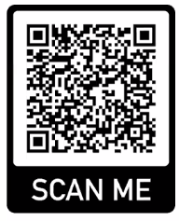

Register for these webinars now!
The webinars will be recorded and posted on EPA’s website.

Recycling Education and Outreach Grants (Total funding: $75M):
- For states, tribes, territories, local governments, and other organizations to fund projects to improve consumer education and outreach.
Goal of Grants:
- Support education and outreach on consumer recycling and waste prevention
- Inform public on what is accepted in community recycling program
- Increase collection rates and decrease contamination in recycling
Eligible Applicants:
- U.S. States, including Washington, D.C.
- Puerto Rico, Virgin Islands, Guam, American Samoa, Commonwealth of Northern Mariana Islands.
- Local governments.
- Federally recognized tribal governments.
- Native Hawaiian organizations, Department of Hawaiian Home Lands, Office of Hawaiian Affairs.
- Nonprofit organizations.
- Public-private partnerships.
Deadlines:
- Applications for funding are due January 16, 2023
EPA Webinars:
- Overview of request for application, eligible entities, evaluation criteria, application process, and answer questions (same presentations)
  - November 30, 2022 @ 2:00pm – 3:30pm (EST)
  - December 6, 2022 @ 6:00pm – 7:00pm (EST)
- Review procurement, sub awards, and answer questions (same presentations)
  - December 15, 2022 @ 2:00pm – 3:30pm (EST)
  - December 20, 2022 @ 6:00pm – 7:00pm (EST)

Register for these webinars now!
EPA Regional Contacts:
Region 6 | Robert Snowbarger  Amber Howard  Renee Bellew | Snowbarger.Robert@epa.gov  Howard.Amber@epa.gov  Bellew.Renee@epa.gov

Online Resources:
https://www.epa.gov/rcra/solid-waste-infrastructure-recycling-grant-program#about
https://www.epa.gov/rcra/recycling-education-and-outreach-grant-program

